VIDYAVARDHAKA COLLEGE OF ENGINEERING
(Autonomous, affiliated to VTU)

DEPARTMENT OF
COMPUTER SCIENCE AND ENGINEERING

A Mini-Project Report on

“URL Safety Checker”
Submitted in partial fulfillment of the requirement for the completion of IV semester of
BACHELOR OF ENGINEERING

Submitted by:

Pradeep | 4VV24CS205
Pratheek | 4VV24CS216
Praneel M D | 4VV24CS213

Course Name | Advanced Python Programming
Course code | BCSAP407
CO | Explore various programming tools and techniques in a team.
PO | PO3, PO5 and PO8
PSO | PSO1

Under the guidance of:
Prof. Susan Shaju
Assistant Professor Dept. of CSE

Vidyavardhaka College of Engineering,

Gokulam 3rd Stage, Mysuru – 570002,
Department of Computer Science and Engineering,



CERTIFICATE

This is to certify that the Mini Project report on Advanced Python Programming entitled “URL Safety Checker” has been successfully completed by the students (Names and USNs) of IV Semester, Computer Science and Engineering, Vidyavardhaka College of Engineering, Mysuru, in partial fulfillment of the requirements for the award of the degree of Bachelor of Engineering in Computer Science and Engineering of Visvesvaraya Technological University, Belagavi, during the academic year 2024–2025.

Signature of Internal Guide Signature of HoD

Name of Examiners Signature with Date
1.
2.

Abstract

Why we chose this project

We chose this project to address the increasing threat of phishing and malicious websites on the internet. The URL Safety Checker helps users identify potentially unsafe links using simple and effective security checks. It also provides practical experience in Python programming, cybersecurity concepts, and user interface development

The URL Safety Checker is a Python-based cybersecurity application designed to help users identify potentially malicious, phishing, or fraudulent websites before accessing them. With the rapid growth of online transactions, digital communication, and internet-based services, cybercriminals increasingly use deceptive URLs to steal sensitive information such as passwords, banking details, and personal data. This project aims to provide a simple and user-friendly solution for evaluating the safety of a URL through automated analysis.

The system examines multiple characteristics of a URL, including the use of HTTPS protocol, the presence of direct IP addresses instead of domain names, excessive URL length, and suspicious keywords commonly found in phishing attacks. Each factor contributes to a scoring mechanism that generates a safety score and categorizes the URL as Safe, Suspicious, or Unsafe. The results are displayed through an interactive graphical interface developed using Python's ipywidgets and HTML styling, making the application accessible and easy to use.

In addition to providing a safety rating, the system explains the reasons behind its assessment, helping users understand common indicators of unsafe websites. This educational aspect promotes cybersecurity awareness and encourages safer browsing practices. The project demonstrates the practical implementation of Python programming, regular expressions, URL parsing, event-driven interfaces, and rule-based decision-making techniques.

Although the current version relies on predefined security rules and does not connect to external threat intelligence databases, it effectively illustrates the fundamentals of phishing detection and website risk assessment. Future enhancements may include integration with machine learning models, domain reputation services, WHOIS analysis, SSL certificate verification, and real-time malware detection APIs. Overall, the URL Safety Checker serves as a valuable learning project in cybersecurity and software development while providing a useful tool for improving online safety and user awareness

Problem Statement
How can a Python-based system automatically analyze a URL and determine whether it is safe, suspicious, or potentially malicious using security indicators such as HTTPS usage, URL length, IP address detection, and suspicious keywords?

Objective

• To develop a Python-based URL Safety Checker:
Build an application that analyses website URLs and determines their safety level. The system provides users with a simple way to evaluate links before visiting them. It helps improve online security through automated URL assessment.

• To identify potentially malicious and phishing URLs:
Detect suspicious websites that may attempt to steal personal or financial information. The system uses predefined security rules to recognize common phishing indicators. This helps users avoid fraudulent and harmful websites.

• To verify HTTPS usage:
Check whether a website uses the secure HTTPS protocol. HTTPS ensures encrypted communication between the user and the website. URLs without HTTPS are considered less secure and receive a lower safety score.

• To detect IP-based URLs:
Identify URLs that use IP addresses instead of domain names. Such URLs are often associated with phishing and malicious activities. Detecting them helps improve the accuracy of security assessments.

• To analyse URL length:
Evaluate the length of a URL to identify unusually long web addresses. Excessively long URLs can be used to hide malicious content. This check contributes to the overall safety evaluation.

• To detect suspicious keywords:
Search for terms such as "login," "verify," "bank," and "secure" within URLs. These keywords are frequently used in phishing attacks. Their presence may indicate a potentially unsafe website.

• To generate a safety score:
Calculate a numerical score based on the results of various security checks. The score provides a quick indication of a URL’s trustworthiness. Higher scores represent safer URLs.

• To classify URLs based on risk level:
Categorize URLs as Safe, Suspicious, or Unsafe according to their safety score. This classification helps users understand the level of risk. It simplifies the decision-making process for website access.

• To provide detailed analysis and feedback:
Display the reasons behind each safety assessment. Users can understand which factors affected the score. This improves transparency and educational value.

Scope of the Project
The scope of this project is to develop a Python-based URL Safety Checker that helps users evaluate the safety of website URLs before accessing them. The system analyzes URLs using predefined security parameters such as HTTPS availability, IP address detection, URL length, and suspicious keywords commonly associated with phishing attacks. Based on these checks, the application generates a safety score and classifies the URL as Safe, Suspicious, or Unsafe.
The project is intended for educational and basic cybersecurity purposes, providing users with a simple tool to identify potential online threats. It includes an interactive user interface that allows real-time URL analysis and displays detailed feedback. The scope can be extended in the future by integrating machine learning algorithms, domain reputation services, SSL certificate verification, WHOIS lookup, and real-time threat intelligence APIs to improve detection accuracy and functionality

Methodology and Implementation code
• URL Input Collection
- The user enters a website URL through the interactive interface.
• URL Parsing
- The system extracts components of the URL using Python's urlparse module.
• Security Analysis
- The URL is checked for HTTPS usage, IP address presence, excessive length, and suspicious keywords.
• Safety Score Calculation
- Points are deducted for each detected risk factor, and a final safety score is generated.
• Risk Classification
- Based on the score, the URL is classified as Safe, Suspicious, or Unsafe.
• Result Display
- The safety score, classification, and reasons for deductions are displayed to the user through the graphical interface
- • IP Address Detection:
Determine if the URL contains an IP address instead of a domain name.
- • URL Length Analysis:
Measure the length of the URL to identify unusually long web addresses.
- • Suspicious Keyword Detection:
Search for phishing-related keywords like login, verify, bank, and secure
from urllib.parse import urlparse
import re
def check_url(url):
score = 100
reasons = []
parsed = urlparse(url)
# Check HTTPS
if parsed.scheme != "https":
score -= 20
reasons.append("URL does not use HTTPS")
# Check for IP address
ip_pattern = r'(\d{1,3}\.){3}\d{1,3}'
if re.search(ip_pattern, parsed.netloc):
score -= 30
reasons.append("Uses IP address instead of domain")
# Check URL length
if len(url) > 75:
score -= 15
reasons.append("URL is too long")
# Check suspicious keywords
suspicious_words = [
"login", "verify", "secure",
"update", "bank", "account",
"free", "bonus"
]
for word in suspicious_words:
if word in url.lower():
score -= 10
reasons.append(f"Suspicious keyword: {word}")
# Determine status
if score >= 80:
status = "SAFE"
elif score >= 50:
status = "SUSPICIOUS"
else:
status = "UNSAFE"
return status, score, reasons
# Main Program
url = input("Enter URL: ")
status, score, reasons = check_url(url)
print("\n===== URL ANALYSIS REPORT =====")
print(f"URL: {url}")
print(f"Status: {status}")
print(f"Safety Score: {score}/100")
print("\nReasons:")
if reasons:
for reason in reasons:
print("-", reason)
else:
print("- No issues detected")

Output Screenshot

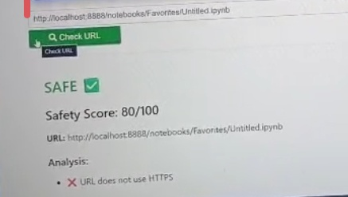

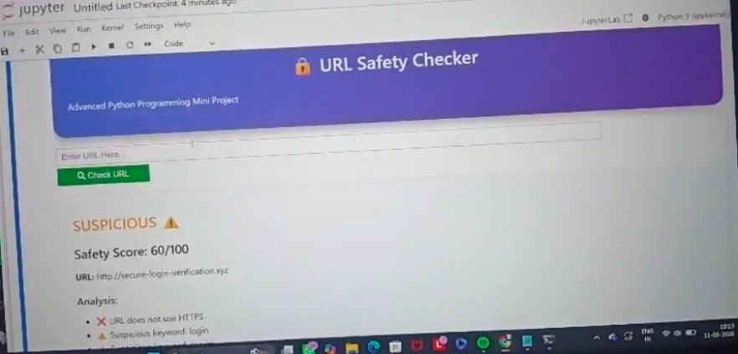

Advantages and Disadvantages

Advantages

- Easy to use with a simple and interactive user interface.

- Quickly analyses URLs and provides instant results.

- Helps identify potentially malicious and phishing websites.

- Improves user awareness of online security threats.

- Uses a lightweight rule-based approach with low resource requirements.

- Provides detailed explanations for the safety assessment.

- Can be easily modified and enhanced with additional security features.

- Useful for educational and cybersecurity learning purposes.

Disadvantages

- Relies on predefined rules and may not detect all phishing websites.

- Does not verify website reputation through external security databases.

- Cannot detect newly created or sophisticated malicious websites.

- Does not analyse webpage content or behaviour.

- May generate false positives or false negatives in some cases.

- Does not perform SSL certificate validation.

- Limited accuracy compared to advanced machine learning-based systems.

- Requires further enhancements for real-world cybersecurity deployment

Application

• Phishing Detection:
Helps users identify potentially fraudulent and phishing websites before accessing them.

• Safe Internet Browsing:
Assists users in making informed decisions about the safety of website links.

• Cybersecurity Education:
Serves as a learning tool for understanding URL-based security threats and phishing techniques.

• Academic Projects:
Can be used as a mini-project or research project in Python programming and cybersecurity courses.

• Personal Security:
Helps individuals avoid malicious websites that may steal personal or financial information.

• Corporate Awareness Programs:
Can be used in organizations to educate employees about online security risks.

• Browser Security Enhancement:
Acts as a basic URL screening tool before visiting unknown websites.

• Foundation for Advanced Security Systems:
Can be extended with machine learning models and threat intelligence APIs for real-world cybersecurity application

Conclusion

The URL Safety Checker successfully analyses website URLs and helps users identify potentially unsafe or suspicious links. It uses security checks such as HTTPS verification, IP address detection, URL length analysis, and suspicious keyword identification to evaluate the safety of a URL. The system generates a safety score and provides clear feedback, enabling users to make informed decisions before visiting a website.
This project demonstrates the practical application of Python programming and basic cybersecurity principles in developing a useful security tool. It is simple, efficient, and easy to use, making it suitable for educational purposes and cybersecurity awareness. Although the current system is rule-based, it provides a strong foundation for future enhancements such as machine learning integration, domain reputation analysis, and real-time threat intelligence services. Overall, the project contributes to promoting safer internet browsing and increasing awareness of online security threat

Evaluation sheet

Criteria | Max. marks | Student1 name and USN | Student2 name and USN | Student3 name and USN
Demonstration | 05
Viva | 05
Report | 10
Total | 20

